**Cell Segmentation and Extraction from DIC Images - Tutorial**

Johns Hopkins University, Wu Lab

Author: Sun Jay Yoo

Edited: June 19, 2017

*Cell segmentation from DIC images relies upon the ImageJ Morphological Segmentation plugin, which is part of the MorphoLibJ[1] library. This tutorial aims to guide users in the installation of this plugin, basic segmentation, and individual segment selection (cell extraction)*

# **Installation[2]:**

1. Start FIJI updater by selecting *Help > Update…*
2. Click on *Manage update sites[3]* and activate the *IJPB-plugins[4]*
3. Close and apply changes
4. Restart FIJI

# **Basic Segmentation:**

1. Open FIJI and open desired DIC .tif image.
2. Once the image has opened, select the Morphological Segmentation plugin from *Plugins > MorphoLibJ > Segmentation > Morphological Segmentation*. A GUI interface will open for this plugin.

[The following instructions are for generic cell border images with reasonable contrast, but settings may vary.]

1. Under Input Image, set as a border image.
2. Under Watershed Segmentation, turn on Advanced Options, uncheck Calculate Dams.
3. To find the appropriate level of segmentation, set tolerance on the order of thousands and adjust accordingly. Lower tolerances result in more segmentation. If the desired segmentation cannot be achieved, change the Connectivity in the Watershed Segmentation section.
4. Under Results, adjust Display to personal preference. Overlaid Basins show colored segments superimposed over the original image, Overlaid Dams show segmentation lines superimposed over the original image, Catchment Basins show the colored segments, and Watershed Lines show only the segment lines.
5. Click Create Image to output a segmented .tif image for saving and post-processing.

**Advanced (Macros):**

To semi-automate the segmentation process, a complete macro example is shown below:

**//Enter in filepath of .tif image**

**open("/FILEPATH.tif");**

**//Run plugin**

**run("Morphological Segmentation");**

**wait(1000);**

**//Run watershed segmentation**

**//Change tolerance level from default of tolerance=6200 to achieve appropriate results**

**//Lower numbers mean more segmentation and vice versa.**

**//Dams are calculated and are set at 8.**

**call("inra.ijpb.plugins.MorphologicalSegmentation.segment", "tolerance=6200", "calculateDams=true", "connectivity=26");**

**//Option 1: Segmentation with just watershed lines**

**//call("inra.ijpb.plugins.MorphologicalSegmentation.setDisplayFormat", "Watershed lines");**

**//Option 2: Segmentation with the watershed lines superimposed over original image**

**//call("inra.ijpb.plugins.MorphologicalSegmentation.setDisplayFormat", "Overlaid dams");**

**//Option 3: Segmentation image with colored basins**

**//call("inra.ijpb.plugins.MorphologicalSegmentation.setDisplayFormat", "Catchment basins");**

**//Option 4: Segmentation image with colored basins superimposed over original image**

**//call("inra.ijpb.plugins.MorphologicalSegmentation.setDisplayFormat", "Overlaid basins");**

**//Create segmented image from selected option**

**call("inra.ijpb.plugins.MorphologicalSegmentation.createResultImage");**

**Examples:**

|  |  |  |
| --- | --- | --- |
| DIC Image Input |  |  |
| Overlaid Dams Output | Tolerance = 7000  Connectivity = 8 |  |
| Overlaid Dams Output | Tolerance = 6200  Connectivity = 8 |  |
| Overlaid Basins Output | Tolerance = 6200  Connectivity = 8 |  |
| Watershed Lines Output | Tolerance = 6200  Connectivity = 8 |  |
| Catchment Dams Basins | Tolerance = 6200  Connectivity = 8 | /Users/sunjayyoo/Desktop/Screen Shot 2017-05-24 at 11.42.15 AM.png |

# **Cell Extraction (Segmentation Selection) [with examples]**

1. Once a cell image is reasonably segmented (at least more segmented than what it should be), it is possible to merge segments and extract desired regions of interests. It is best to set the Results to Display as Catchment basins.

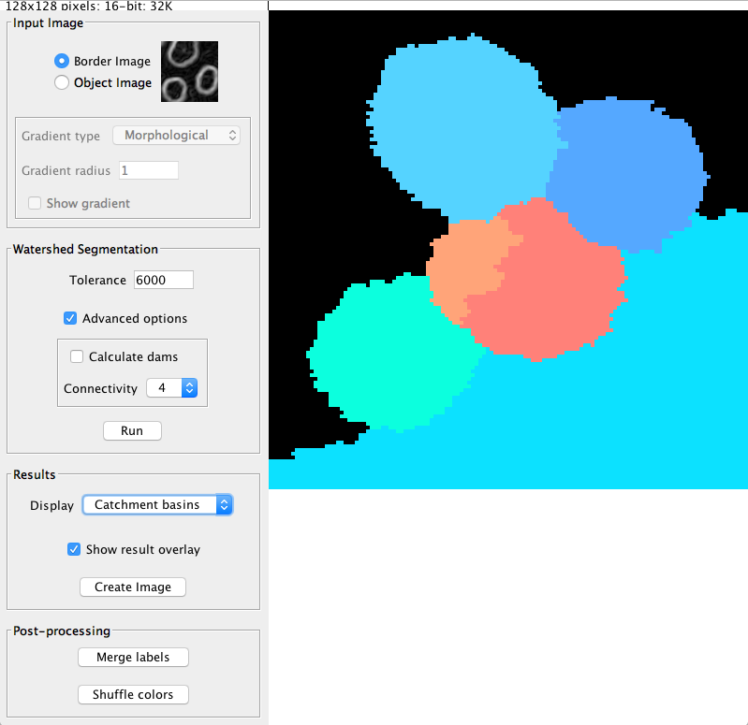

1. Select Create Image in the Results section. Once the image is created, select the Label Edition in *Plugins > MorphoLibJ > Label Images > Label Edition.*

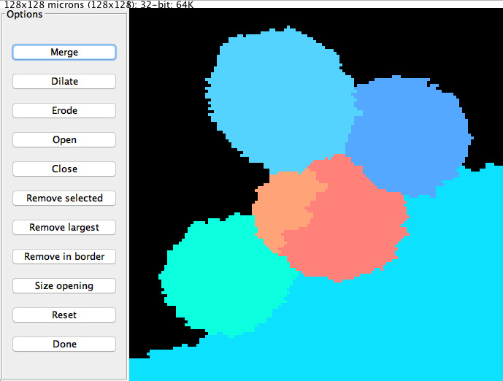

1. In order to extract the region of interest, the noise from the other segments must first be removed. Click on all segments that are outside the region of interest and select Remove selected. In this example, the region of interest is the top two cells.

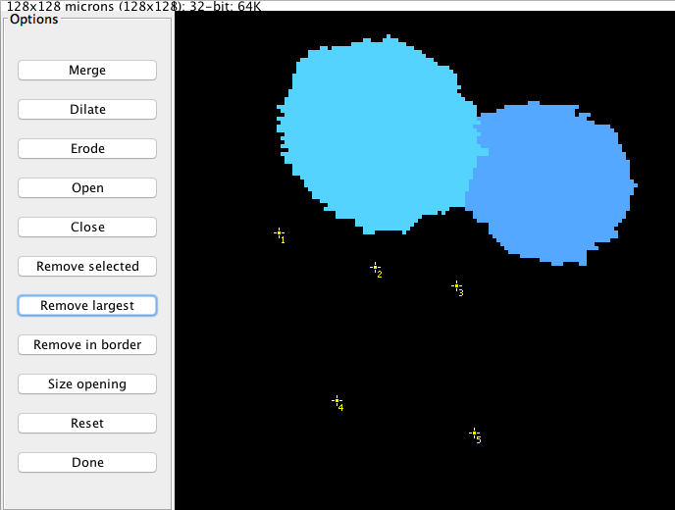

1. To merge the region of interest into one segment, click on all segments in the region of interest and select Merge and then Done.



1. In order to turn the image into a black and white image mask, select the ImageJ Threshold command from *Image > Adjust > Threshold…*
2. Ensure that the Threshold method is Default and set the color to B&W. Ensure that the Dark background option is deselected. Close the Threshold window and the image mask of the region of interest should now be created.

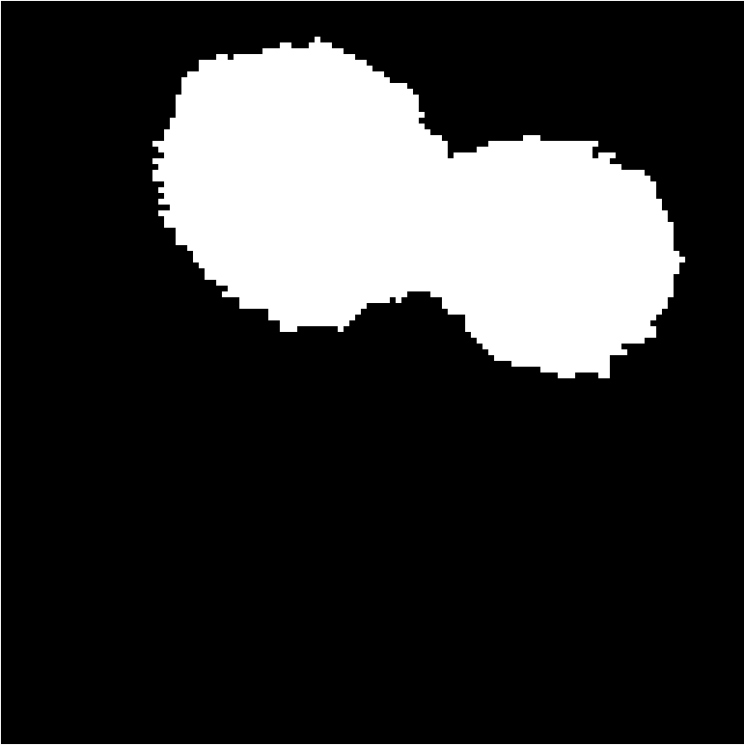

# **References:**

1. <https://imagej.net/MorphoLibJ>
2. <https://imagej.net/Morphological_Segmentation>
3. <https://imagej.net/Following_an_update_site#Add_update_sites>
4. <https://github.com/ijpb/MorphoLibJ>